Project ID :
25-26J-153
- Topic (12 words max)
GovConnect: A Smart ICT Framework for Automated Civil Complaint Management and Citizen Engagement in Sri Lanka

- Research group the project belongs to
AIMS - Autonomous Intelligent Machines and Systems

- Specialization of the project belongs to
Information System Engineering(ISE)

- If a continuation of a previous project:
Project ID | 25-26J-153
Year | 2025

- Brief description of the research problem including references (200 – 500 words max) – references not included in word count.
In Sri Lanka, the public grievance management typically remains slow, manual, and inefficient. Citizens are required to submit complaints usually via paper forms or phone calls, that are then normally manually assigned and routed by government officials. This creates delays and significant uncertainty, while manual sorting opens the possibilities of misclassification. There are no standard ways for the government to give priority or assess the expected time for resolution of a grievance, meaning issues of public safety (a larger issue) become classified with issues that are of much smaller significance.
This is compounded in rural areas where many citizens have digital literacy challenges and face language barriers. Many complaints are filed informally and in a mixed Sinhala-English language that many automated systems cannot detect, resulting in many grievances being ignored or misassigned. In addition, government officials and staff do not have analytical tools to indicate how long a complaint may take to resolve, which creates more uncertainty when it comes to prioritization of complaints and becomes solely dependent on each individual's judgment.
To fill this gap, GOV Connect LK is proposed as a two-part AI-based platform. Firstly, it uses a Sinhala/English Natural Language Processing (NLP) model to automatically classify complaint type (and detect urgency) based on complaint text that is free text. Secondly, it uses a Machine Learning (ML) model to predict expected resolution time (based on historical or simulated data). The outputs of the models are coupled to community voting signals to provide a dynamic priority score to each complaint.
It also includes an active dashboard feature for use by government officers that allows them to engage and respond to complaints based on the calculated priority. The unique aspect of this research lies in its development of a fine-tuned Sinhala NLP model that can accommodate informal and code-mixed language. It also features a hybrid prioritization algorithm that incorporates urgency, resolution feasibility and community signals. GOV Connect LK has the potential to provide faster, smarter and fairer public service delivery throughout Sri Lanka.

- Brief description of the nature of the solution including a conceptual diagram (250 words max)
The digital complaint management system, GOV Connect LK was designed to manage public issues both in urban and rural areas of Sri Lanka. The platform provides support for Sinhala, English, and code-mixed languages, to enable every citizen access, for residents to report complaints on issues such as hospital staff shortages, potholes, water supply disruptions, missed pickups for garbage collection, school infrastructure Issues . It also connects with Ministries- health, education, highways, water supply, environment, public administration, transport, power and energy, agriculture and labor.
GOV Connect LK is made up of two components. First, a language processing engine which analyses the text of a complaint, without needing an additional software application, and classifies it automatically into categories (for example health, roads, water) and urgency (high, medium, low). The classified complaints can then be routed to the appropriate ministry. Second, a data-driven model which looks at previous complaints and estimates completion timelines and feasibility factors to estimate how long the issue could take, and how realistic it is to address it, again assisting with prioritizing complaints that are likely to have the greatest impact.
Citizen engagement is also possible with the ability to vote on complaints others have posted, and bring greater visibility to issues that many others are feeling (they all might even define the issue differently). Complaints that have been submitted are ranked in ministry dashboards according to Urgency, expected resolution time, and number of votes.
This procedure enables transparency, leads to quicker resolution of issues, and better service delivery of public services to the community which will amplify the voice of citizens in governance.
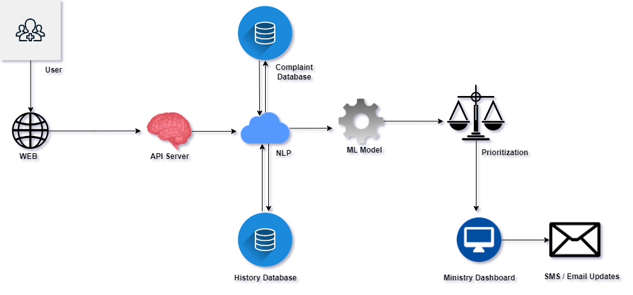

conceptual diagram

- Brief description of specialized domain expertise, knowledge, and data requirements (300 words max
In order to develop the GOV Connect LK app, we will need two types of data; (1) messages from people (for understanding language); and (2) previous complaint records (to help model how long things take to resolve).
To start with, we need approximately 12,000 complaint messages in Sinhala, English or both. These need to be labeled in terms of complaints being about (e.g road, water, electricity) and how serious they are (critical, high, medium, low). We plan to use government sourced data like the 1919 hotline, the "tell the president" web page, and local councils. We will also utilize complaints made in public posts on Facebook and Twitter, and we will create a simulation form for people to make complaints. This form will be promoted via the university network, youth groups and community organizations to collect examples of common complaint styles.
The complaints would be annotated according to a simple process. Each complaint should be read and annotated once by trained bilingual annotators. To ensure quality, we will compare the annotation results and reconcile any discrepancies. In order to protect the privacy of individuals in complaints, no personally identifiable information will be included.
Second, we will need data on resolved complaints, at least 8,000 real complaints - more if we will be using fake but realistic complaints. This includes the complaint's type, the unit that resolved the complaint, and the time to resolution. This will be collected from the records kept by government councils or ministry systems. If needed, we may combine this with computer-generated information to create realistic examples. This data would be collected for an 8-day period from August to February to support the development of GOV Connect LK.

- Objectives and Novelty
Main Objective
The main goal is to design and develop a digital complaint management system that applies natural language processing in Sinhala and English (NLP) and machine learning (ML to automatically classify, prioritize, and route complaints submitted by citizens. The overall aim is to enhance the efficiency, transparency, and responsiveness of government service delivery in Sri Lanka.
Member Name with Registration No | Sub Objective | Tasks | Novelty
IT22593900-  D.M.C. Shehara | - To create a complaint classification system that can also understand informal Sinhala, English, and code-mixed texts, and then integrate this system into a real time, citizen-facing application that captures citizen input and does NLP analysis to allow for the automated classification and prioritization of complaints. | - Compile and prepare a labeled dataset of complaint texts with annotations for urgency and category.  - Preprocess and normalize informal Sinhala language including slang and code-mixed.  - Fine-tune a transformer (e.g., mBERT or Sinhala BERT) model to classify urgency and category.  - Build and deploy an NLP microservice using FastAPI or Flask.  - Integrate the NLP output via the complaint submission workflow and backend.  - Evaluate model performance using accuracy, precision, recall, and F1 score. | Finetuning a Sinhala NLP model to handle informal, low - resource, and code-mixed language an underexplored area in public service technology ensuring accessibility for rural and underserved communities.
IT22607782-W.M.B.S.Premalal | - Create a resolution time prediction model for public complaints based on historical or simulation data, implement the prediction model within a hybrid prioritization system & officer dashboard focused on real-time decision-making that considers urgency, predicted resolution time, and community voting. | - Collect or simulate a dataset of complaints with resolution time, department, urgency, and type.  - Train a regression model (e.g. XGBoost or Random Forest) to predict resolution time.  - Create a hybrid priority score equation that utilizes urgency, predicted time, and community voting.  - Build all of the backend system (Node.js + Express) to store complaints, route API requests and generate priority scores.  - Create an interactive officer dashboard (React.js) that including sorting capabilities, filtering, and analytic visualizations.  - Incorporate feedback loops for updating complaint statuses, and notifying users. | Introduces a hybrid prioritization algorithm that combines urgency (NLP output), ML-predicted resolution time, and public voting to support smarter and faster complaint resolution in real-world governance systems.

- Individual component description of how it is complied with the specialization.
Member Name with Registration No | Description
IT22593900-  D.M.C. Shehara | This component employs natural language processing (NLP) to classify complaints written in Sinhala-English and identify urgency. It implements a historic finetuned Sinhala BERT model within a system based on FastAPI, allowing for inclusive, intelligent citizen engagement by real-time, multilingual processing of -citizens’ complaints and enabling public services that adapt to citizens expressed needs.
IT22607782-W.M.B.S.Premalal | This element applies to creating a regression model to predict complaint resolution time and combining that with urgency and votes to allow for task prioritization. A full-stack system with dashboard features offers intelligent, data-driven decision-making for public service.

- Supervisor details
 | Title | First Name | Last Name | Signature
Supervisor | Lecture | Buddhima | Attanayake
Co-Supervisor | Lecture | Narmada | Gamage
External Supervisor
Summary of external supervisor's (if any) experience and expertise

This part is to be filled by the Topic Screening Staff members.

- Does the chosen research topic possess a comprehensive scope suitable for a final-year project?
Yes |  | No

- Does the proposed topic exhibit novelty?
Yes |  | No

- Do you believe they have the capability to successfully execute the proposed project?
Yes |  | No

- Do the proposed sub-objectives reflect the students' areas of specialization?
Yes |  | No

- Supervisor's Evaluation and Recommendation for the Research topic:

Acceptable: Mark/Select as necessary
Topic Assessment Accepted
Topic Assessment Accepted with minor changes*
Topic Assessment to be Resubmitted with major changes*
Topic Assessment Rejected. Topic must be changed

* Detailed comments given below
Comments

Staff Member’s Name | Signature

*Important:
- According to the comments given by the evaluator, make the necessary modifications and get the approval by the Evaluator.
- If the project topic is rejected, identify a new topic, and request the RP Team for a new topic assessment.

